The Value of Catchment Groups in times of Adversity

Take home messages

- Have a well established catchment group
- Know your numbers
- Tell your story
- Have a town base
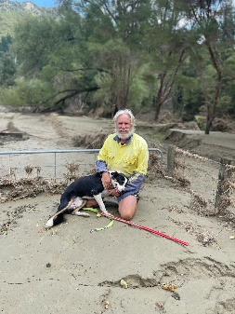
Week 1
- Door to door assessment
- Applied for support on behalf of farmers
- Coordinated volunteers
- Build a plan.
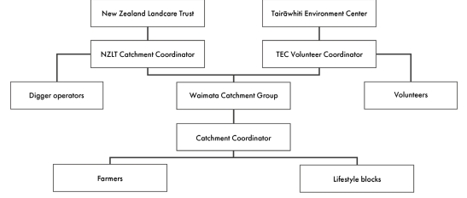

The equation of health
- Repaired infrastructure = $ + animal welfare.
- Fixed $ flow + animal welfare = stress alleviated.
- Alleviation of stress = we don't lose businesses or people.
Tell your story
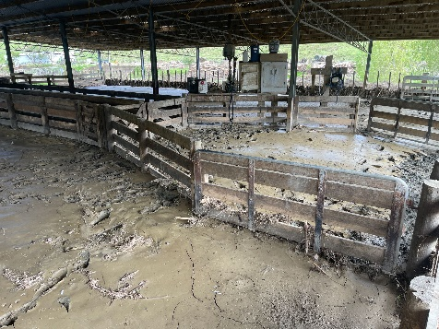
- Video
- Images
- Have a face for your campaign
- Story = support
- Your story brings in $, diggers, volunteers and resources.
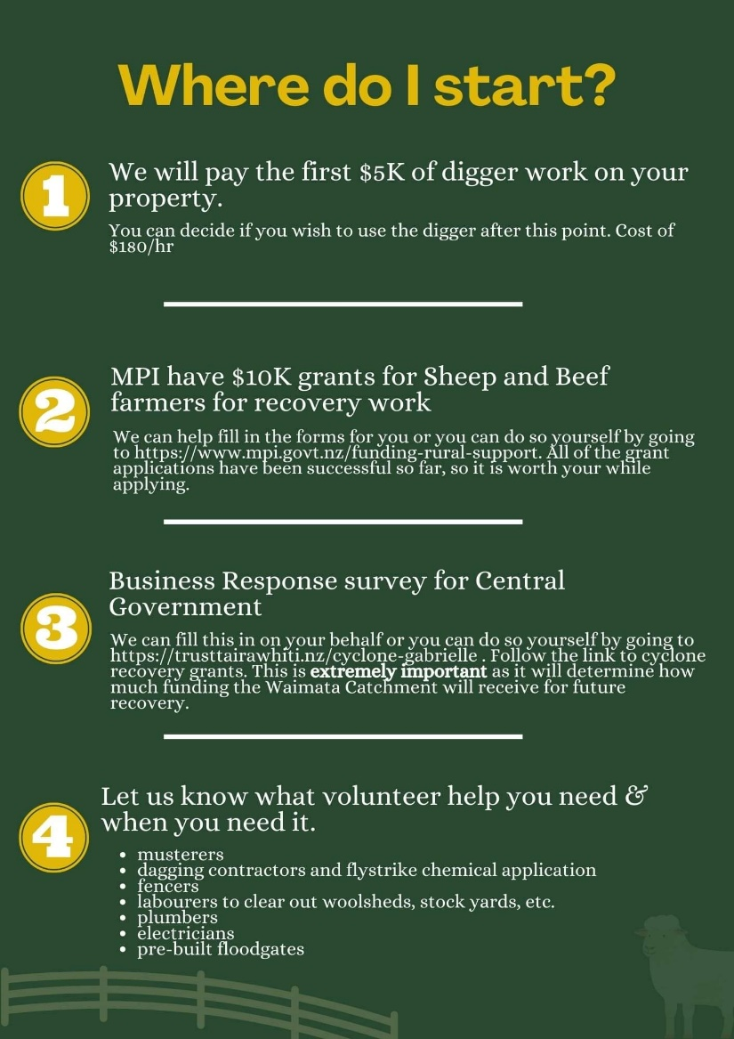
Week 2

- Communicate a clear plan forward.
- Volunteer fatigue.
- Capitalise on funding now!

Know your numbers
- How many properties
- Km’s of boundary fence
- Km’s river frontage
- Km’s primary and secondary tracks
- Ha of river flats
- A solid contact list
Urban Volunteers
- People want to help
- A volunteer coordinator is key
- You need tools, food, trailers and a jobs list
- These volunteers free farmers up to farm
Week 3
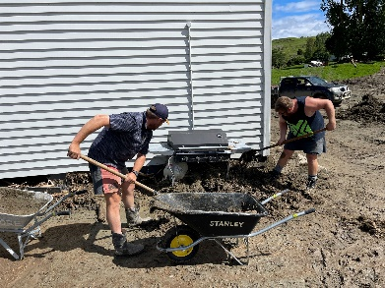
- Govt support should be kicking in.
- Community resilience wavers.
- Coordinator exhaustion.
- Your situation is old news…
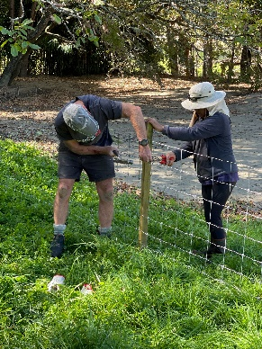
Week 4
- Bring in outside resources.
- Deliver on funding goals and farmer priorities.
- Back off workload.
- Apply for funding and volunteer support.
Week 5 onwards
- It’s not going away in a hurry…
- Build a solid report that can generate more $
- Ministers and media are looking for positive stories. Contact them directly

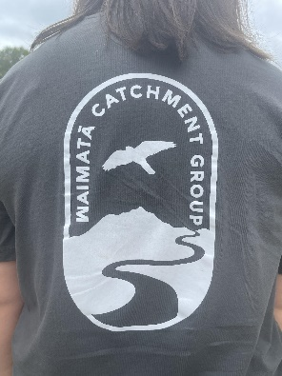
In the end it comes down to community

- Catchment groups are key
- A town base
- Great coordinators
- Tell your story
- Act fast

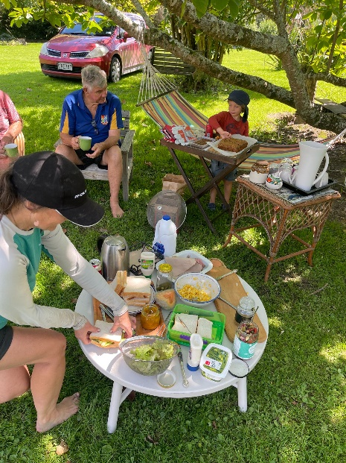
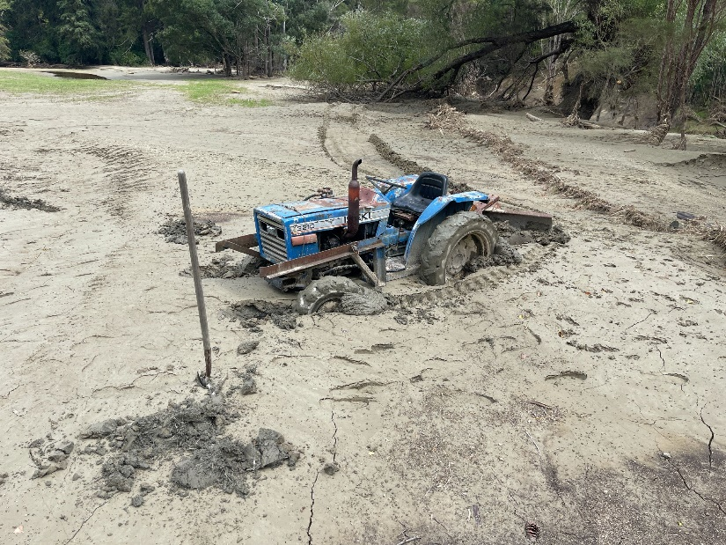
We are grateful to Sam Gibson – Te Tairāwhiti NZ Landcare Trust Coordinator for sharing these learnings

Notes Prepared by Otago Catchment Community from Sam Gibson’s June Presentation to Otago Communities, 2023

